A camera-trap survey investigating the use of pools by terrestrial mammals in the non-perennial Prins River system

by

**Ayesha Hargey**

**Student number: 3650393**

Mini-thesis submitted in partial fulfilment of the

requirements for the degree BSc. (Hons.) in

**Biodiversity and Conservation Biology**

**Supervisor: Prof. J A Day**

**Co-Supervisor: Dr. B Maritz and Dr M. Grenfell**

18 November 2019

**Content Page**

**Acknowledgements** 3

**Abstract** 4

**Introduction** 6

Non-perennial rivers 6

Sampling animal communities 9

**Methods and Materials** 15

Study area 15

Survey design 18

Data analysis 21

**Results** 23

**Discussion** 35

**References** 41

# Acknowledgements

I wish to express my gratitude towards my supervisors Professor Jenny Day, Doctor Bryan Maritz and Doctor Michael Grenfell for their support, guidance and encouragement with regards to this thesis project. I further wish to thank the Department of Biodiversity and Conservation Biology at UWC for all resources and assistance. This thesis is a contribution to the multidisciplinary research project on non-perennial rivers being carried out by the Institute for Water Studies at the University of the Western Cape. Finally, I wish to thank the National Research Foundation for funding my studies.

# Abstract

Non-perennial rivers account for more than half of the total river-length in South Africa. Despite their abundance, they are rarely studied due to their highly variable nature. Few studies exist that focus on the faunal components of the non-perennial river habitat, and of those, they are predominantly focused on the aquatic invertebrate assemblages that inhabit these areas. Using camera traps, a survey was performed along the non-perennial Prins River in the Klein Karoo to investigate the use of persisting pools in the riverbed by terrestrial mammals. Camera stations were active for 1280 camera trap days and spanned three different pools along the river. A total of 14 terrestrial mammal species were recorded, encompassing five orders (Primata, Carnivora, Rodentia, Ungulata and Lagomorpha). The most commonly photographed species were the Chacma baboon *(Papio ursinus*), steenbok (*Raphicerus campestris*) and cattle (*Bos taurus*). Detections were found to be higher as a result of motion-triggered photography than at hourly intervals by a factor of more than ten. It was found that detection rates increase in summer. No relationship was found between water availability and detection rate, however, species richness and total detections are highest following a flood that recharged the river. Each non-perennial river system is unique due to their differences in hydrology as well as spatial and temporal changes and consequently require individualized studies. This study represented the first species inventory of the mammalian assemblage of the Prins River. Future investigations should be undertaken on other non-perennial rivers in South Africa with the goal of more sustainable management of these important environments.

**Keywords**: biodiversity, camera trap, terrestrial mammals, non-perennial, rivers, Klein Karoo

# Introduction

## Non-perennial rivers

River systems in arid landscapes across the world that undergo intermittent cessation of water flow are known as non-perennial rivers. There exists a deficit in research towards these systems despite their abundance, as rivers that dry up occasionally make up more than half the river-length in South Africa as well as globally (Raymond *et al*., 2013, Day *et al*., 2019). Terminology used to describe these river systems is inconsistent, some authors using ‘intermittent’ (Datry, Larned and Tockner, 2014) and others ‘ephemeral’ (Matthews, 1988), among other terms, but all are ‘non-perennial rivers’. Unlike their perennial counterparts which are associated with a predictable nature, non-perennial rivers are complex, highly variable aquatic ecosystems impacted by changes in a mixture of standing water, flowing water and dry terrestrial riverbed (Uys and O’Keeffe, 1997; Day *et al*., 2019). This is because they are impacted by changes in flow regime that leave them periodically flooded or dry. Furthermore, they are affected by the pools of standing water which remain in them during dry periods (Day *et al.*, 2019). As a result of their variability, they are challenging systems for the terrestrial mammas dependent on the water contained within them (Jacobson, 1997) — as well as the researcher who studies this environment, leaving a noticeable gap in research to non-perennial rivers (Steward *et al*., 2012). Yet, they are very important to both people and wildlife living in the vicinity, providing the scarce resource of water in the dry surroundings (Day *et al*., 2019). In the same way that non-perennial rivers are difficult for certain mammalian species to live in, they are equally challenging to manage but this does not mean they should be underrepresented by policy-makers. Rivers that run dry should no longer be considered atypical, but rather, as being part of a global phenomenon.

Although non-perennial rivers in South Africa are significant in size and extent, these environments are largely ignored in research and in management (Uys and O’Keeffe, 1997; Datry, Arscott and Sabater, 2011). Climate change has adjusted flow regimes, and the lack of understanding regarding the ecological impacts of this has led to policies based on unverified assumptions (Uys and O’Keeffe, 1997). With an increase in predicted droughts as a result of the warming of the climate, an increase in the abundance of non-perennial rivers is expected as well as an increase in the duration over which they remain dry (Meehl *et al*., 2007). Consequently, this has the potential to heavily impact the fauna dependent on these rivers.

A river recharges itself with water, allowing the reconnection of populations of aquatic organisms in previously isolated pools, as well as flows of organic matter and nutrients (Steward *et al*., 2012). When the river dries up again, it can act as a corridor for the movement of terrestrial organisms (Sánchez-Montoya et al., 2016). Many dry riverbeds contain minimal trees, ensuring limited obstructions and making it favourable as a means of migration. Herbivorous mammals and many carnivores use dry rivers as means to trace remaining waterholes (Mills and Retief, 1984). Arid environments are typically associated with high daily temperatures and high evaporation rates. Compounded with water scarcity, this environment leaves a challenge for larger mammal species such as ungulates that cannot take refuge in shelters in the same way that smaller vertebrates can (Grenot, 1992). Furthermore, Grenot (1992) notes that evaporative heat loss is an essential component for the maintenance of homeothermy. This becomes relevant when considering the decrease in available water sources in arid areas. Many of the small-bodied vertebrate species found in this environment have limited potential to store body water and need to replenish their water intake frequently (Smit *et al*., 2019). Smit *et al*. (2019) also found that the probability of drinking is higher on hot days, and further predict that under climate change conditions, more species will rely on available surface water.

Non-perennial rivers have value to humanity. This environment has been described as a ‘linear oasis’ due to the vegetation inside these corridors being richer in retained organic matter than the surrounding habitat. In comparison to perennial rivers, there is no constant water flow which moves through the fertile soil (Kassas and Imam, 1954). Many carnivore species congregate along non-perennial river courses due to the higher density of herbivorous prey close to the river, and as a result some of these predators are considered residents of the area (Coetzee, 1970). Cattle have been observed frequently grazing on the plants along non-perennial river beds (Kassas and Girgis, 1964). Steward *et al*. (2012) states that there is a poorly researched but important ecotone represented by a river transcending from a habitat that is aquatic to one that is terrestrial and it is this ecotone is responsible for maintaining the diversity in species composition.

Of relevance to this study is the common trait of non-perennial rivers sustaining pools of water in the riverbed (Seaman et al., 2016). The pools tend to persist even when the rivers aren’t flowing, and are important as often they are the sole water source. Romer (1958) has even theorized that it was the drying of pools in non-perennial rivers which caused sufficient environmental pressure that led to the evolution of water-independent movement traits in vertebrates, allowing them to venture onto land. Furthermore, it is also theorized that resistance to desiccation in aquatic vertebrates evolved as a response to the drying out of pools (Williams, 2005). Thus, they have importance both today and historically.

Non-perennial river research is uncommon despite their prevalence around the world, and the unique microhabitats contained within and around them (Datry, Arscott and Sabater, 2011). Previous studies on the faunal component of non-perennial rivers are vastly skewed towards invertebrates, and among those, studies such as Sánchez-Montoya *et al.* (2018) and Chester and Robson (2011) are skewed towards those that are aquatic. There is a major bias in research towards research involving perennial river networks, and this becomes even more concerning when dry rivers are expected to increase as water abstraction and land use alteration changes the environment (Datry, Larned and Tockner, 2014). Thus, there is a need for further studies pertaining specifically to mammals within this important environment.

## Sampling animal communities

Worldwide, there is an increasing prevalence of camera trap usage to monitor and inventory terrestrial faunal assemblages, with particular emphasis on mammals (Cusack *et al*., 2015). Despite mammals being some of the most charismatic animals, it is difficult to study them in a non-invasive manner using traditional methods as they are frequently nocturnal, avoid human presence and are noted for their elusive nature (Gonthier and Castañeda, 2013). Furthermore, in the case of predators, physical handling can be difficult and their secretive habits and low densities can make detection difficult (Kauffman *et al.*, 2007). Despite the challenges associated with their observation, mammals play a significant role in the ecosystem. An example of such is their role in seed dispersal and predation, with grazers and browsers being important in the regulation of plant species populations (Redford, 1992). Their presence in the environment also mediates complex habitat dynamics (Terborgh *et al*., 2008). Camera traps can be seen as a valuable aid in documenting presence, assessing identity and estimating abundance of mammals, which are all factors to be considered in conservation actions (Cusack *et al.*, 2015). Remote camera traps can be used to inventory the presence of large mammals, frequently under environmental pressures such as habitat loss.

In an attempt to preserve the natural environment, there has been a consistent shift towards non-invasive sampling (Tobler *et al*., 2008). Camera traps can be used to collect data that would prove difficult to collect otherwise. Because past research involved time-consuming techniques (such as capturing live individuals) or resulted in detrimental environmental impacts (Kauffman *et al*., 2007), it is understandable that there is an effort to use methods that do not affect the natural habitat in a permanent capacity. Camera traps allow a remotely activated camera to take photographs of an area (Wong and Kachel, 2016). This technology has improved in quality and decreased in cost, and provides reliable evidence of species present (Tobler *et al*., 2008). For this reason, camera traps are seen as one of the best modern methods of data collection for many ecological disciplines. Photographs taken by camera traps can then be analyzed to calculate species richness in an area, which in turn can be used to compare diversity and, at a broader scale, used in conservation planning strategies, as the data obtained can be used to improve species distribution maps (Tobler *et al.*, 2008).

One of the ways in which camera trap surveys can be used is the process of capture-recapture. These techniques have been used to estimate population density of a target species, usually those that have individuals that can easily be identified, such as tigers (*Panthera tigris*) (Karanth and Nichols, 1998). This is useful, particularly in cases where the study species is elusive and would otherwise prove difficult to measure. Another use of the data gathered from camera trap surveys is species occupancy modelling which, along with estimating the probability of detection, uses presence-absence data to estimate the probability of occurrence, allowing estimation of the biodiversity of an area (Cove *et al*., 2013). These models have been continuously updated and refined, most notably by Tobler *et al*. (2015) which utilized data over multiple surveys, and was then able to estimate species presence with higher accuracy, as well as for species with minimal data. Models such as these are useful when camera trap effort is high, and can then be used to investigate patterns in community composition and distribution over long periods of time, an aspect that would be useful when attempting to investigate, as an example, the effects of climate change on a particular habitat. However, many camera trap studies cannot give absolute numbers of population of a given area. This is due to a limitation of camera trap data as it is difficult to distinguish between different individuals for many species. This would then affect the analysis as it would not be possible to discern between multiple or single visits by a particular organism (Kauffman *et al*., 2007). Tobler *et al*. (2008) investigated camera trap efficiency for rainforest mammals and found that the position of camera and area covered have little impact on survey results, as long as camera density is high and one accounts for variation in major habitat types.

In violation of traditional random sampling, camera traps are frequently placed at points that animals are thought to frequent, such as watering holes or trails (Cusack *et al.*, 2015). Thus, it is important to acknowledge the inherent bias in some studies. Cusack *et al.* (2015) did show, however, that given sufficient sampling activity, species richness can be ascertained and camera placement does not affect inferences made at a community level. This suggests that as long as a study encompasses a long enough time period, a level will reach at which the majority of the community will be accounted for, regardless of whether cameras were placed randomly or not.

Detection rates can vary between species (Mann *et al*., 2014). Camera trap placement is important when considering survey design, as different species favour different environments (Edwards, Gange and Wiesel, 2016). Designing camera trap surveys which increase probability of detection is ideal due to the naturally low populations of many species occurring in arid environments (Hayward, O’Brien and Kerley, 2007). While smaller mammals may prefer the safety of off-trail vegetation, it was found that certain carnivores are exclusively detected by cameras on trails (Edwards, Gange and Wiesel, 2016). If a particular species is targeted for study, placement is not the only factor that can influence detection. Certain surveys use bait, for example the use of a fish lure when detecting brown hyenas (*Hyaena brunnea*) (Thorn *et al.*, 2009). This technique is undesirable due to the risk of permanent habituation around the site, which would not reflect an accurate depiction of the environment (Balme, Hunter and Robinson, 2014). While baiting certainly has advantages in increasing detection, as well as individual identification, it is not without consequences. Those at the greatest risk are charismatic carnivores such as lions (*Panthera leo*), leaving them more vulnerable to activities that use bait stations, such as trophy hunting (Balme, Hunter and Robinson, 2014). However, Edwards *et al.* (2016) put forth the idea of water sources as “natural bait”, since typical arid environments lack this essential resource. An advantage of camera placement at natural water sources is that it comes with none of the detriments of introduced bait. Additionally Edwards *et al*. (2016) found that camera traps placed at a water source produced higher detection probabilities than cameras away from water sources, and that some animals, such as fox species (*Vulpes* and *Otocyon*), were not at all detected except at a water source. This shows the importance of including a water source when attempting to provide an inventory for an environment that includes one.

With this knowledge, the use of camera traps along a non-perennial river can provide a useful representation of the environment. There are, however, no known camera trap studies published on non-perennial rivers in South Africa.

The study site is within the Klein Karoo, and projections show that water demand will continue to increase for this area as well as South Africa as a whole (Maitre, Colvin and Maherry, 2009). This makes it an ideal location for one of the first studies on the mammalian wildlife component of a non-perennial river. The aim of this project is to investigate the use of pools by the terrestrial mammals of the Prins River. The objectives of this study are thus:

* Firstly, to establish an inventory of terrestrial mammals that occur along the Prins River
* Document the assemblages of terrestrial mammals that are directly and indirectly affected by the presence of pools
* Examining diurnal variation in detection of terrestrial mammals
* Furthermore, camera efficiency will be tested through the use of motion-triggered images and images taken at timed intervals
* Finally, the project aims to record the changes in fluctuations in surface-water availability and the effects of this on the detection of individual animals

This study will provide the first documented inventory of the mammals found at the non-perennial Prins River, taking place along three locations along the Prins River, along a gradient of pool water availability.

The study is a component of the research undertaken by the multidisciplinary Non-Perennial Rivers Research Programme, a project led by the Institute of Water Sciences that is concentrating on understanding the relationships between river flow, ecosystem characteristics and services provided by non-perennial rivers. This research can then be used to facilitate decision making and management of non-perennial rivers.

# Methods and Materials

## Study area

The area known as the Klein Karoo occurs in the Western Cape, South Africa (Figure 1). It is known for its semi-arid climate which is where three separate biomes (Fynbos, Succulent Karoo and Subtropical Thicket) meet (Mucina and Rutherford, 2011). This results in an ecosystem known for its ecological diversity and indeed, the Fynbos and Succulent Karoo biomes are recognized as global biodiversity hotspots (Driver *et al*., 2003). Despite the importance of this region, a legacy of mismanagement and poor agricultural practices has left the land exploited (Thompson *et al*., 2005). The nature of the arid environment means that water is a scarce resource, and indeed, important for further development (Thompson *et al*., 2005). Climate change is predicted to have an effect on the climate regime, with warmer temperatures predicted, as well as a predicted increase in rainfall in summer months and a decrease in winter months (Maitre, Colvin and Maherry, 2009).

The Prins River is a tributary of the Touws River, one that has persisting pools that are not frequently connected to the larger river network. There is a need to investigate the significance of these pools in supporting the faunal component as Jacobson (1997) noted that non-perennial water sources support certain animal species in arid environments. These pools subsist even when the river stops flowing, and are thus sources of water. The study site is known for variable summer rainfall, with major floods expected at unpredictable intervals. It has a low rainfall (100-250mm yr-1), mean summer temperatures >30°C and mean winter temperature of 4-8°C (Maitre, Colvin and Maherry, 2009). As identified by Maitre *et al*. (2009), there is a lack of information on water systems in the Klein Karoo.

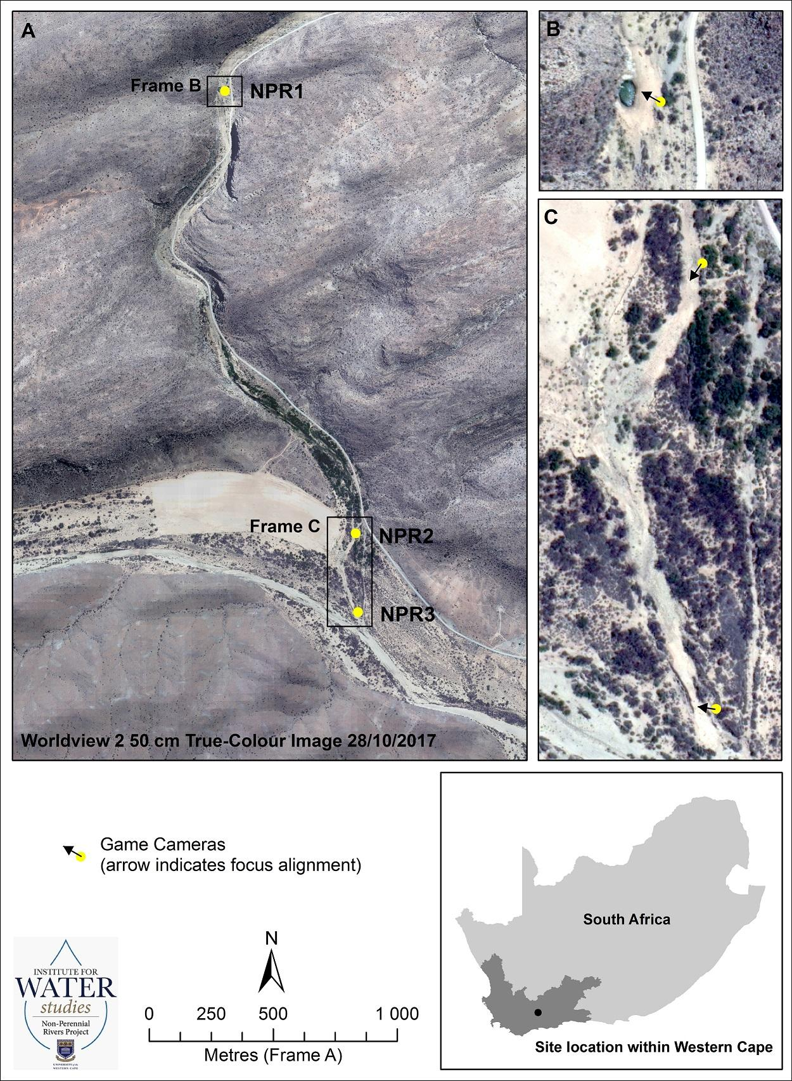

|  |
| --- |
| **Figure 1: Study area and location of camera trap stations, located along the Prins River, a tributary of the Touws River and showing the location of the Klein Karoo in South Africa (inset)** (Source: M Grenfell) |

## Survey design

A camera trap survey was carried out from 20th April 2017 to 21st June 2018 along the Prins River. It spanned 2.4km in total. Locations chosen were specifically targeted at naturally-occuring pools in the river. The survey included three sites, selected by the project coordinators and therefore beyond the control of this thesis project. The first camera (NPR1) was placed at a pool filled with water for the duration of the study (Figure 1, Frame B) , with the other two cameras (NPR2 & NPR3) situated at sites without perpetual water (Figure 1 Frame C). The total duration of the survey was 427 days. Bushnell cameras (Bushnell Outdoor Products, Overland Park, KS, USA) were set to capture photographs every hour, as well as whenever they were triggered by motion. Date, time and temperature were automatically stamped onto each photograph. After the first interval (Table 2), the camera at the permanent pool was set only to take photographs by motion-trigger.Cameras were operating 24 hours a day and batteries were checked and replaced three times over the course of the study.

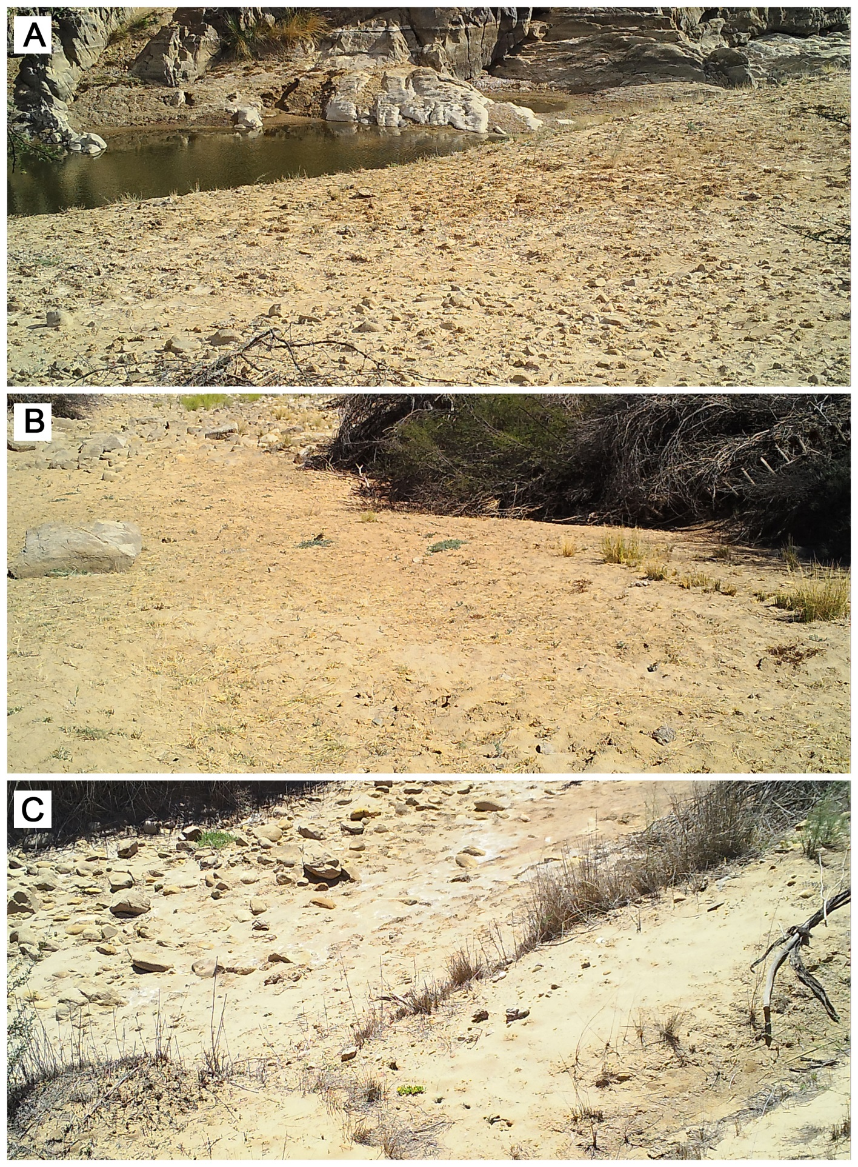**Figure 2: Study location of (A) Camera NPR1. (B) Camera NPR2. (C) Camera NPR3.**

Camera NPR1 faced north across and slightly upstream of the confluence of the Prins River at a large deep pool, with an overhanging face of sandstone above (Figure 2a). There was sparse cover of *Vachellia karroo* on the left bank, according to camera placement. Camera NPR2 (Figure 2b) was placed at a downstream exit of the canyon at the confluence of the Prins and Touws River at a smaller pool. Dense cover of *Vachellia karroo* occured on both banks. Camera NPR3 (Figure 2c) was positioned upstream of the confluence of the Prins and Touws rivers, at a pool similar in size to NPR2. Directly facing the camera is dense cover of *Vachellia karroo* on the left bank, a reedbed of *Phragmites australis* at the lower right bank grading into the *Vachellia karroo*.

## Data analysis

All images were downloaded from SD cards and entered into the software Timelapse2 (Greenberg, Godin and Whittington, 2019), designed for managing camera trap data while maximizing efficiency through rapid data-entry. For each photograph, the station, the temperature, the presence or absence of water, the date and time, and the species detected were recorded. Animals were identified down to species level through the use of Stuarts’ Field Guide to Mammals of Southern Africa (Struik Nature, 2015). Images of animals not identifiable due to lack of clarity were taken into consideration only for detection-based analysis. A relative abundance index (RAI) was calculated as the number of detections per species divided by sampling effort and then multiplied by 100 (thus, a measure of detections per 100 days of camera trapping). It is a common component of many camera trap studies and used for comparable results due to its simple formula, and the way in which it can be used in studies where true abundance would be complex or difficult to calculate (Palmer et al., 2018). RAIs can be used as a measure of population. Furthermore, Palmer *et al*. (2018) deduced that even under conditions with potential bias arising from imperfect detections, RAIs can predict relative abundance with accuracy.

Analyses were carried out in R version 3.5.0 (R Core Team, 2014). Species accumulation curves were plotted using the package vegan (Oksanen et al., 2019). Additionally, I calculated a separate curve for the overall study. This is a measure of the total number of species against the total sampling effort and demonstrates the rate at which new species are being detected within the sampling site (Ugland, Gray and Ellingsen, 2003). It allows the comparison of diversity across sites and is able to predict whether an environment has been sampled to an acceptable level of detection.

Analysis of species richness was carried out only on the subset of data with identified species. Photographs taken by motion-trigger were compared with photographs taken at hourly intervals to determine which had a higher detection rate and thus was more efficient and this was done through the use of a *t*-test. In order to investigate the relationship between whether an increase in water availability would result in an increase in species detection, an ANOVA was done of the time comparing detections during periods of water against detections during periods of water absence. A Chi square was done to examine if any difference in visitation occurred before and after a flooding event, such as that occurred in January 2018 (Figure 2). Diurnal variation in species detection was examined visually through the use of histograms generated using the package camtrapR (Niedballa et al., 2016).

# Results

The overall number of terrestrial mammal species detected was 14, accumulated from a total of 1280 camera trap days across the three sites. Observed false triggers were high, associated with movement of foliage from wind. There were 3 cases of human activity recorded at two of the sites, and excluded from the analysis. While many bird species were captured on camera (141 in total), they were excluded from species analysis as this camera sensitivity is not designed for a robust study on birds.

The fourteen mammal species detected were taxonomically diverse and span across five orders: Primata, Carnivora, Rodentia, Ungulata and Lagomorpha (Table 1). Individual identification was not within the scope of this study. The mammal species most photographed were the Chacma baboon (*Papio ursinus*)*,* steenbok (*Raphicerus campestris*) and cattle (*Bos taurus*)*.* Of the felids, caracals (*Caracal caracal)* and African wild cats (*Felis silvestris cafra*)were both detected on six occasions. There were multiple individuals of greater kudu (*Tragelaphus strepsiceros*), both male and female, of varying ages. Figure 3 demonstrates the changes in water availability for the duration of the study. Images from the study are shown in Figure 4 and 5.

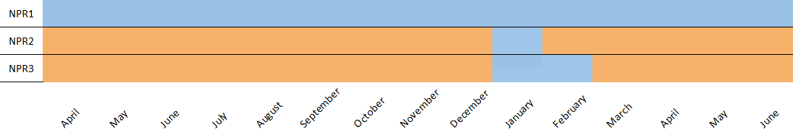

**Figure 3: Presence (blue) or absence (orange) of water at the sites for the duration of the study**

**Table 1: Inventory of photographed species with number of captures and Relative Abundance Indices for all observed mammals during the camera trap survey at the non-perennial Prins River**

|  |  |  |  |  |  |  |
| --- | --- | --- | --- | --- | --- | --- |
|  |  |  | **Site** | | |  |
| **Taxonomic Group** | **Latin name** | **Common name** | **NPR1** | **NPR2** | **NPR3** | **Total** | **RAI** |
| Primata | *Papio ursinus* | Chacma baboon | 76 | 132 | 42 | 250 | 19.3 |
| Carnivora | *Canis mesomelas* | Black-backed jackal | 45 | 13 | 10 | 68 | 5.31 |
|  | *Galerella pulverulenta* | Cape gray mongoose | 0 | 1 | 0 | 1 | 0.08 |
|  | *Felis silvestris cafra* | African wild cat | 1 | 3 | 2 | 6 | 0.47 |
|  | *Caracal caracal* | Caracal | 1 | 3 | 2 | 6 | 0.47 |
|  | *Canis lupus familiaris* | Dog | 0 | 0 | 1 | 1 | 0.08 |
| Rodentia | *Hystrix africaeaustralis* | Cape porcupine | 3 | 0 | 0 | 3 | 0.23 |
| Ungulata | *Tragelaphus strepsiceros* | Greater kudu | 8 | 18 | 17 | 43 | 3.36 |
|  | *Taurotragus oryx* | Eland | 12 | 1 | 4 | 17 | 1.33 |
|  | *Raphicerus campestris* | Steenbok | 3 | 46 | 52 | 101 | 7.89 |
|  | *Oreotragus oreotragus* | Klipspringer | 8 | 1 | 0 | 9 | 0.70 |
|  | *Bos taurus* | Cattle | 27 | 38 | 39 | 104 | 8.13 |
|  | *Oryx gazella* | South African oryx | 0 | 16 | 13 | 29 | 2.27 |
| Lagomorpha | *Lepus saxatilis* | Scrub hare | 0 | 1 | 0 | 1 | 0.08 |
| Aves |  |  | 4 | 11 | 126 | 141 | 11.02 |
| Unidentified |  | Unidentified | 26 | 33 | 25 | 84 | 6.56 |

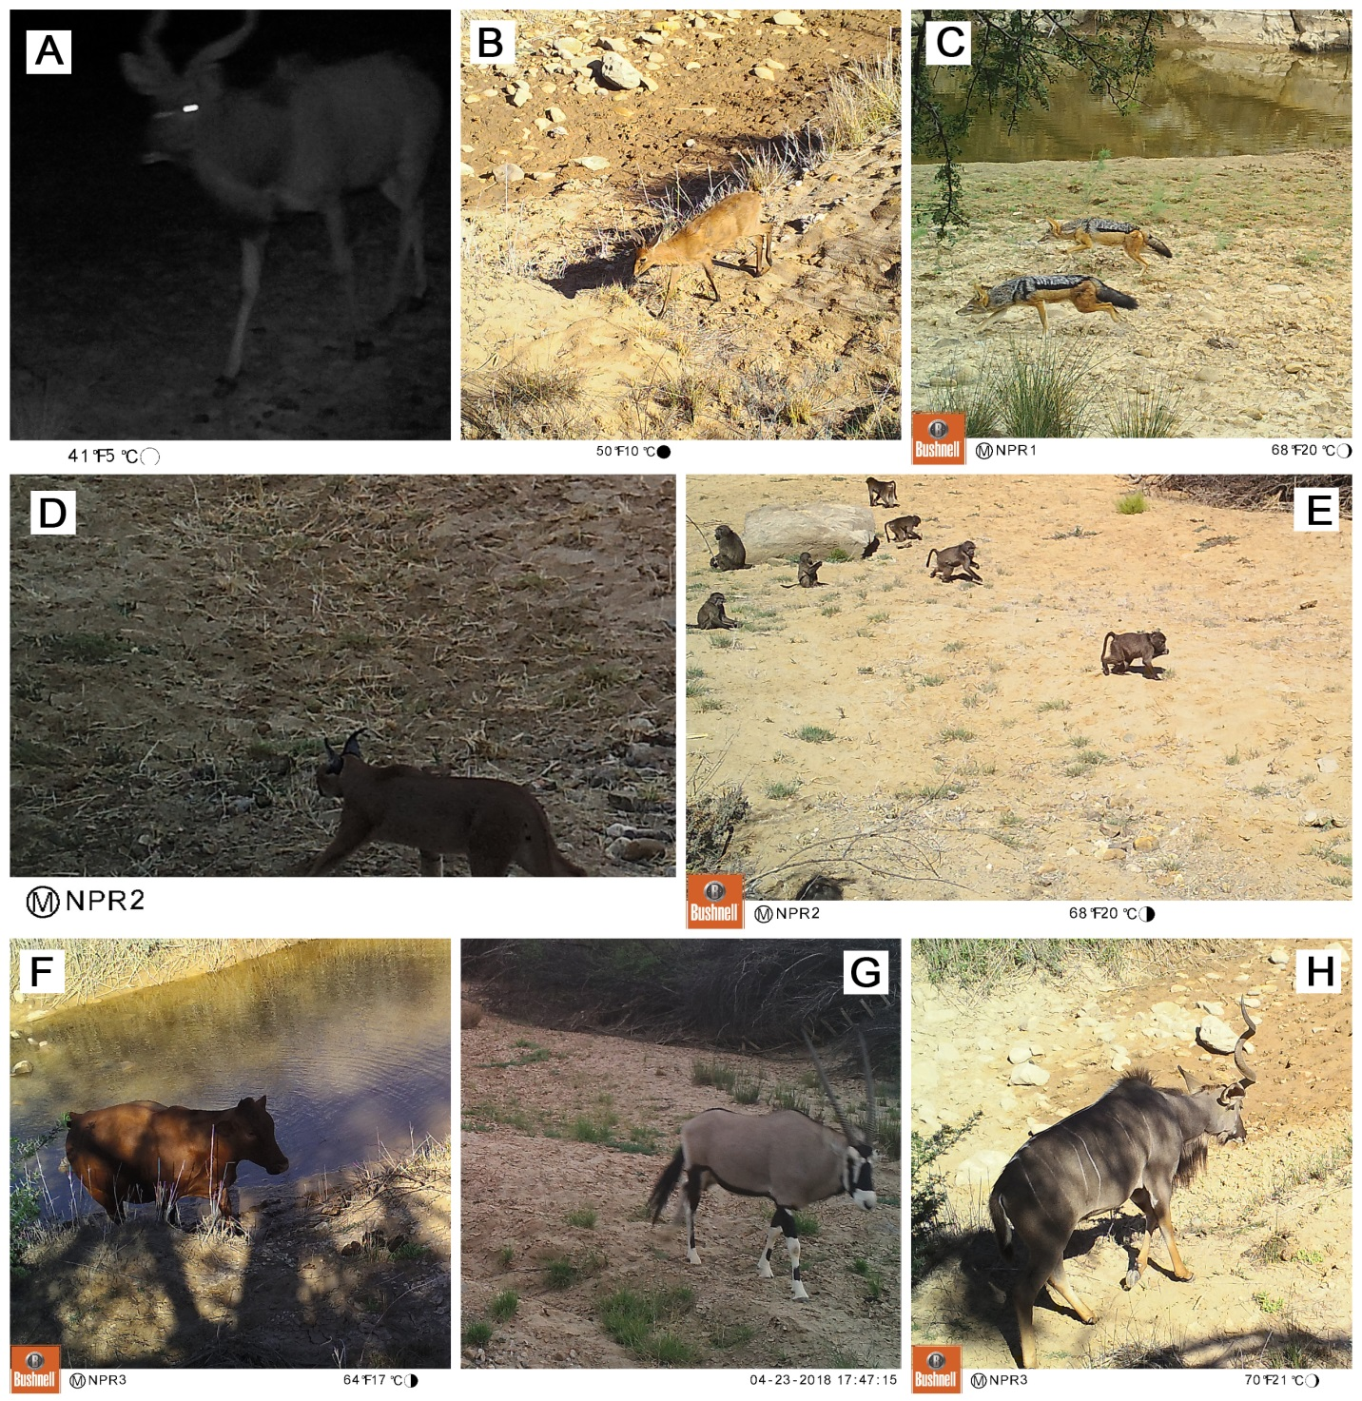

**Figure 3: Camera trapping in the non-perennial Prins River.** (A) Male greater kudu (*Tragelaphus strepsiceros*) during night-time. (B) Steenbok (*Raphicerus campestris*) inside the dry channel. (C) Two black-backed jackals (*Canis mesomelas*). (D) Caracal (*Caracal caracal*) inside the dry channel. (E) A troop of baboons (*Papio ursinus*) inside the dry channel. (F) Cow (*Bos taurus*) inside the water during the flood of January 2018. (G) South African oryx (*Oryx gazella*) (H) A single-horned male greater kudu (*Tragelaphus strepsiceros*).

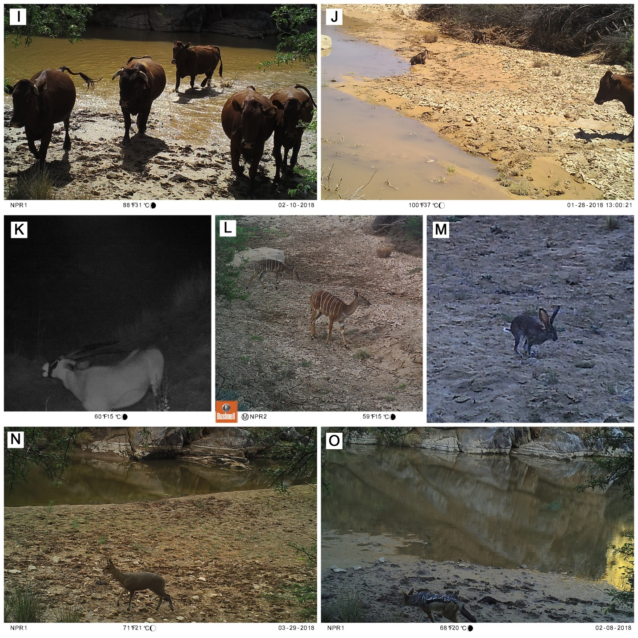

**Figure 4: Camera trapping in the non-perennial Prins River.** (I) Cows (*Bos taurus*) in the flooded pool (J) A cow (*Bos taurus*), and baboon (*Papio ursinus*) drinking from the rapidly drying river (K) South African oryx (*Oryx gazella*) at night. (L) Juvenile greater kudu (*Tragelaphus strepsiceros*). (M) Scrub hare at twilight (*Lepus saxatilis*). (N) Klipspringer (*Oreotragus oreotragus*)(O) Black-backed jackal at the recharged river (*Canis mesomelas*).

To investigate if more animals were detected using motion triggers or timed photographs, the mean number of detections per interval were compared and tested to see if the difference was statistically significant using a two-tailed t-test. The intervals used are shown in Table 2, and represent each time the cameras were checked and batteries replaced. A significant difference was observed (t-testt6 = 3.14; p = 0.02). This demonstrates that detection rate is much higher when photographs are triggered by motion. The difference in detection is greater than a factor of more than twelve (comparing the mean values of 91 against 7.14). The only uncommon individual captured by the hourly photographs was a caracal *(Caracal caracal)*. This suggests that animals that surpass motion detection are more likely to be elusive in nature, such as carnivores.

**Table 2: Summary of total detections and method of trigger for a camera trap survey in the non-perennial Prins River**

|  |  |  |  |  |
| --- | --- | --- | --- | --- |
| Station | Start Date | End Date | Motion | Timed |
| **NPR1** |  |  |  |  |
| Interval 1 | 21/04/2017 | 28/06/2017 | 33 | 4 |
| Interval 2* | 28/06/2017 | 21/11/2017 | 52 | - |
| Interval 3*† | 21/11/2017 | 20/06/2018 | 125 | - |
| **NPR2** |  |  |  |  |
| Interval 1 | 20/04/2017 | 28/06/2017 | 27 | 0 |
| Interval 2 | 28/06/2017 | 21/11/2017 | 70 | 8 |
| Interval 3† | 21/11/2017 | 20/06/2018 | 196 | 16 |
| **NPR3** |  |  |  |  |
| Interval 1 | 20/04/2017 | 28/06/2017 | 21 | 0 |
| Interval 2 | 28/06/2017 | 21/11/2017 | 85 | 1 |
| Interval 3† | 21/11/2017 | 20/06/2018 | 205 | 21 |

*Excluded from t-test analysis as camera only recorded motion-triggered detections

†Heavy rainfall in January 2018 resulted in a flood that recharged the river

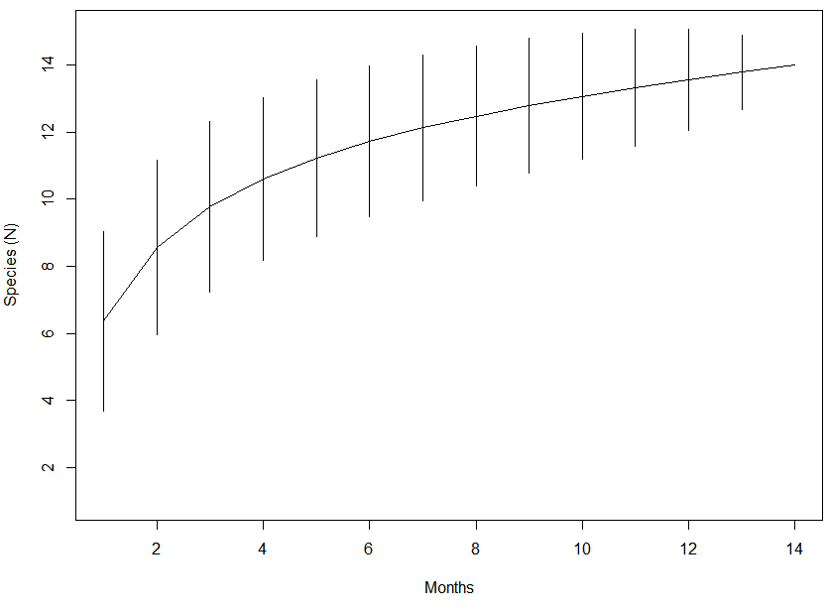

**A**

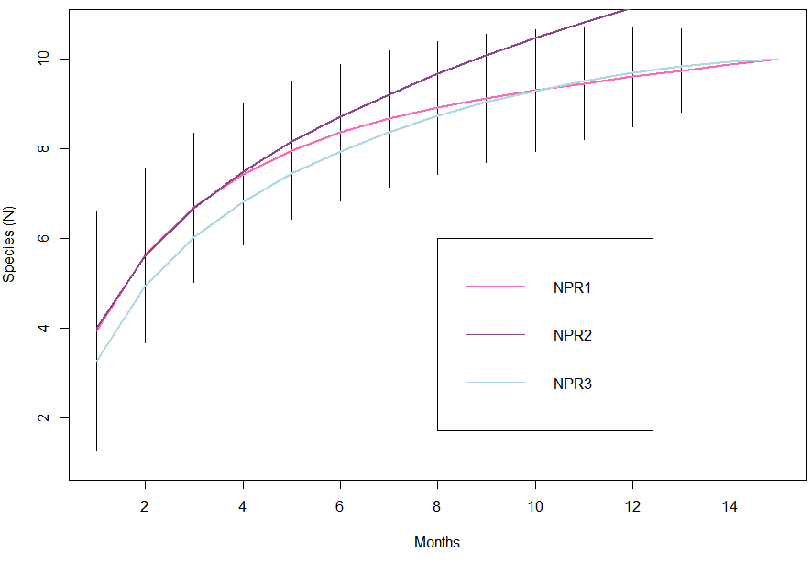

**B**

**Figure 5: Sample-based species accumulation curve describing the terrestrial mammal community richness for the (A) overall study area, and (B) for the three sites. 95% confidence interval displayed as lines.**

The rarefied species accumulation curves (Figure 5b) for two of the three sites (NPR1 and NPR3) are highly similar in the amount of species detected after the eighth month. While these two sites gradually reach an asymptote which suggests the community has been sampled for the full species inventory, NPR2 continues to increase, and suggesting species are still being detected for the first time. Site-specific species richness saw a rapid increase within the five months of study. The overall species accumulation curve (Figure 5a) levels off, suggesting that the environment is close to being sampled entirely, and that it is only through multiple sites that all species were able to be detected. Most likely, any species not detected would be in NPR2 due to the lack of asymptote reached. However this is a model and this suggests that while it is more likely to encounter other species in NPR2, it is not impossible in NPR1 and NPR3. Each site had a minimum of one species that was not detected in the others. The site of highest species richness was NPR2.

A Jaccard similarity index was done in order to quantify similarities in species composition among the environment. There was a high association between the scrub hare (*Lepus saxatilis*) and Cape grey mongoose (*Galerella pulverulenta*). Environments were highly similar, with most species being found in all three sites, with few exceptions. Species that were unique to one site include scrub hare (*Lepus saxatilis*)*,* Cape porcupine (*Hystrix africaeaustralis*), Cape grey mongoose (*Galerella pulverulenta*) and a dog (*Canis lupus familiaris*).

**Figure 6: Average variation in detection frequency of camera traps across all sites for each month of the study duration. Error bars detonate standard error.**

To investigate if seasonality affected detection rates, mean monthly detections across sites were compared (Figure 6) and tested to see if the difference was statistically significant using an ANOVA. A significant difference was found (ANOVA: F11 = 4.86; p < 0001). This shows that detections vary dramatically across the study period. An ad-hoc Tukey HSD was done to determine the source of the difference. There were significant differences found to be between the months April, May, June, July, August, September, October and November against February.

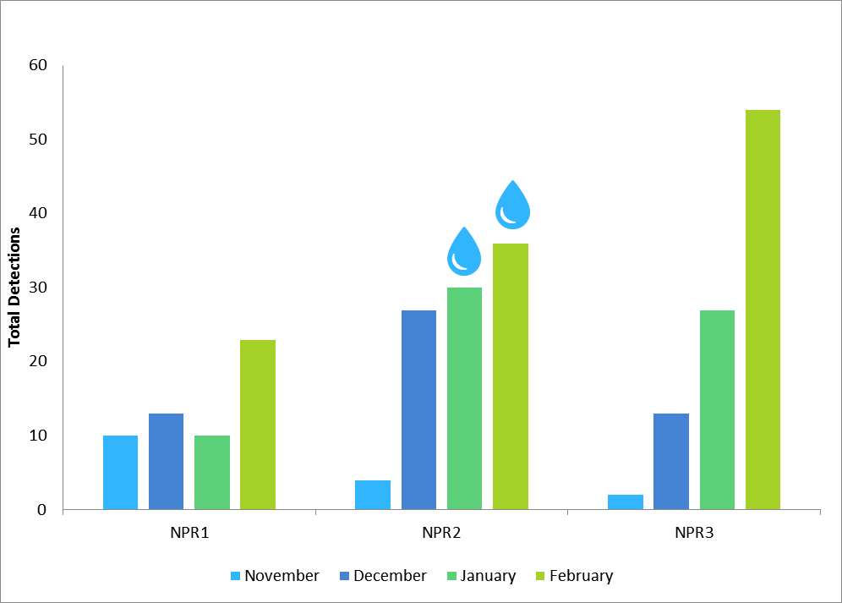

**Figure 7: Total detections for the months preceding and following the flood that occurred in January of interval 3. This flood resulted in the river being recharged. Water droplets represent whether water was present at the pool.**

In an attempt to answer the question if increased water availability increased the visitation rate at the sites, a subset of the total detection data was used for the months November, December, January and February (Figure 7). During late January, a flood occurred which resulted in a flow of water in the pools (Figure 2). To see if this had any effect, an analysis was done consisting of the month in which the flood occurred, and the previous and following months to this. Using a Chi square, sites NPR1 (x2 = 10.67, p = 0.033) and NPR3 (x2 = 31.48, p < 0.001) were found to have a significant variation in visitation rates across these four months. The overall Chi square was found to have a significant variation across all sites (x2 = 19.046, p = 0.004). Detection increases immediately after a recharge event.

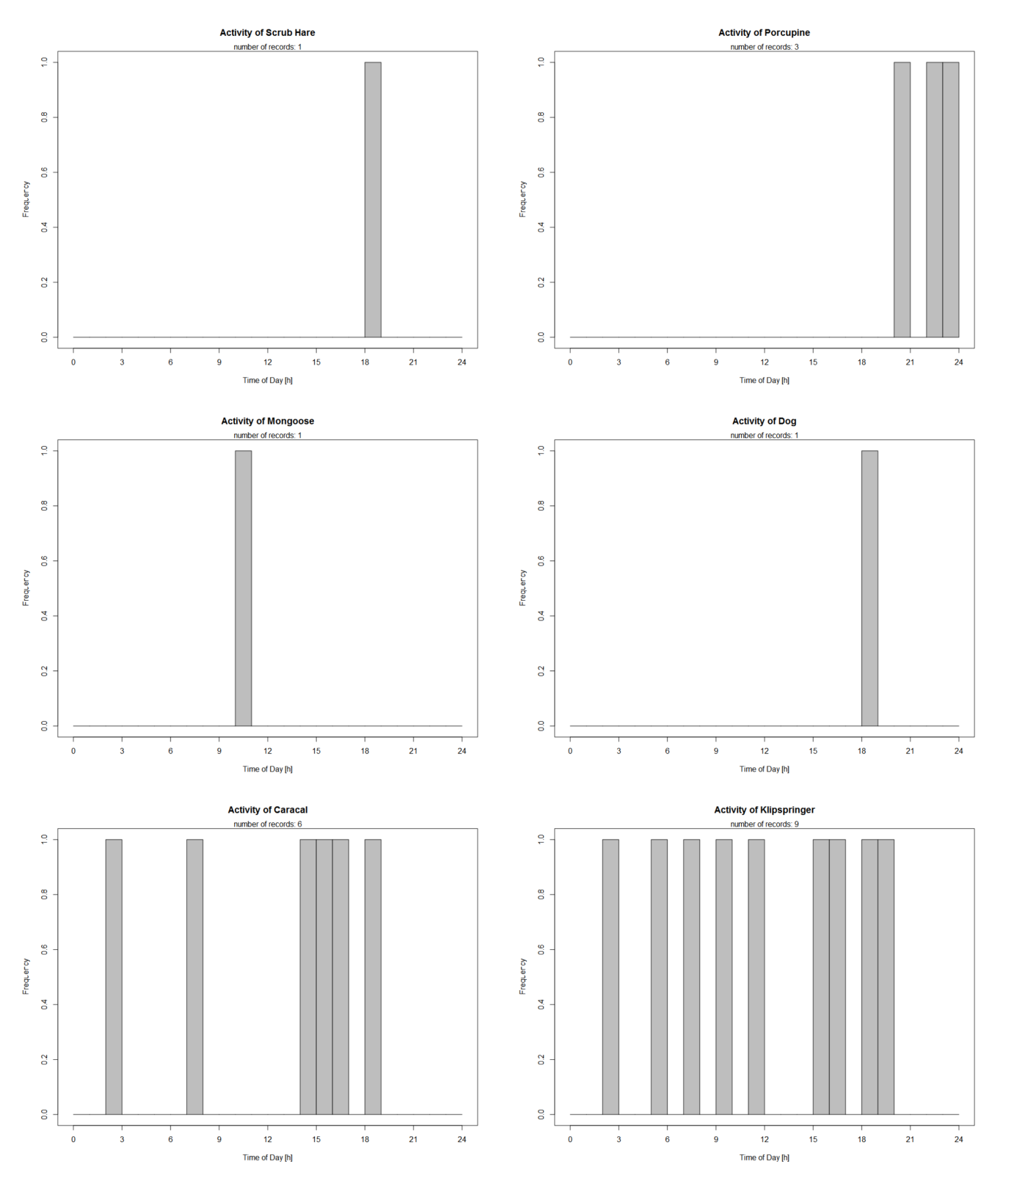

**Figure 8: Histogram displaying the frequency at what time a particular species was detected, accumulated across all sites for species**: scrub hare (*Lepus saxatilis*)*,* Cape porcupine (*Hystrix africaeaustralis*), Cape grey mongoose (*Galerella pulverulenta*), dog (*Canis lupus familiaris*), caracal (*Caracal caracal*) and klipspringer (*Oreotragus oreotragus*).

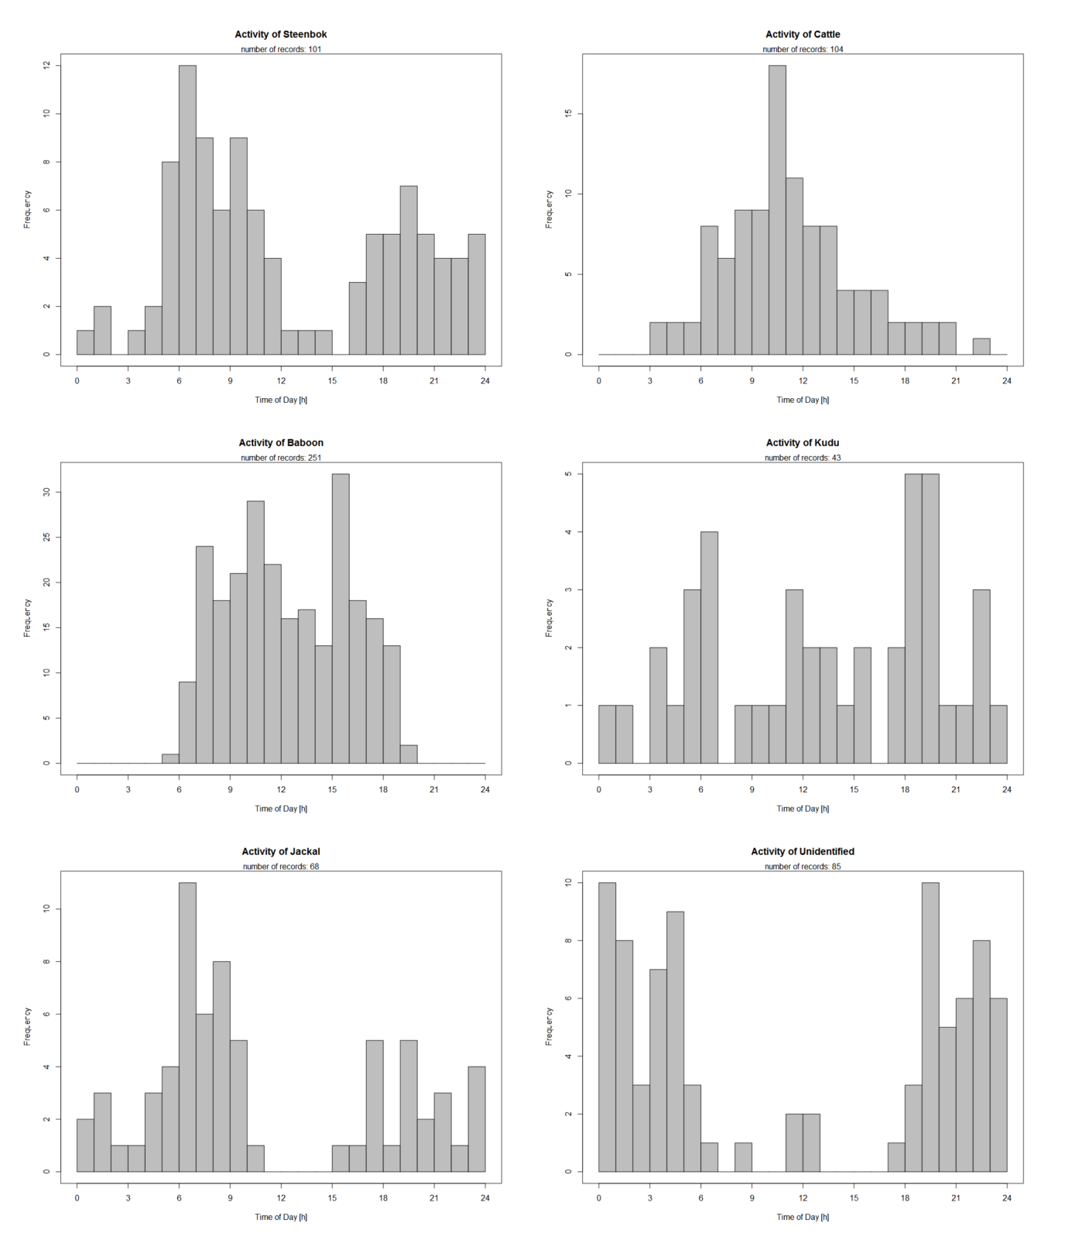

**Figure 9: Histogram displaying the frequency at what time a particular species was detected, accumulated across all sites for species**: steenbok (*Raphicerus campestris*), cattle (*Bos taurus*), baboon (*Papio ursinus*), greater kudu (*Tragelaphus strepsiceros*), black-backed jackal (*Canis mesomelas*) and detections of species that could not be identified.

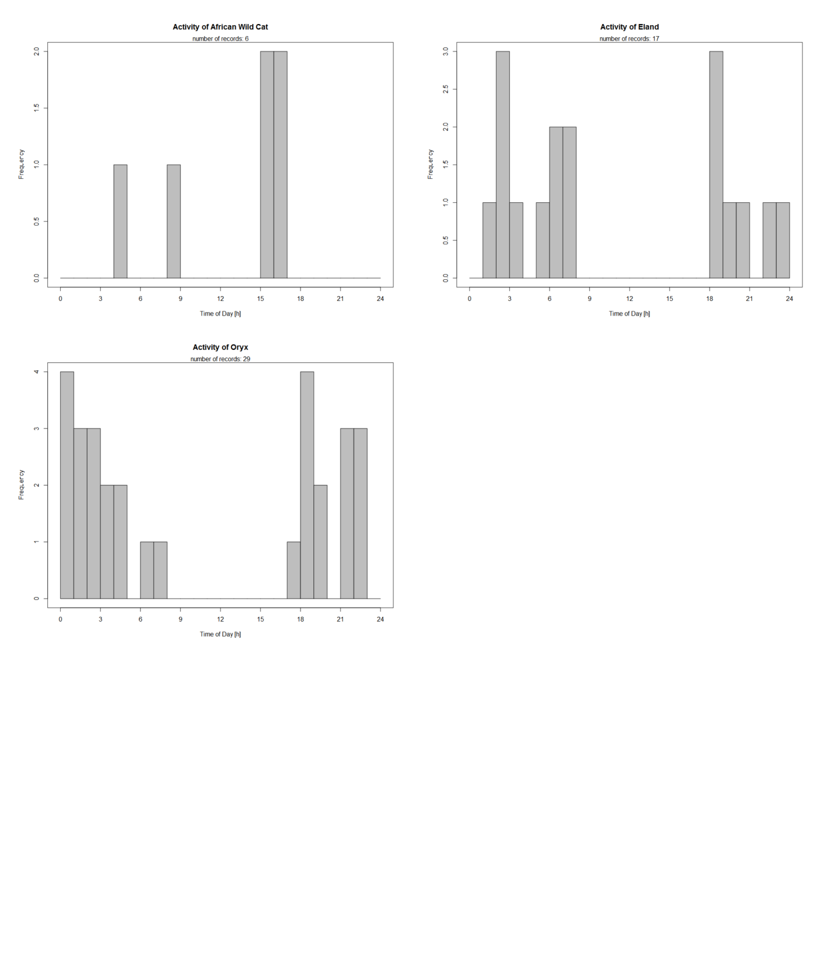

**Figure 10: Histogram displaying the frequency at what time a particular species was detected, accumulated across all sites for species**: African wild cat (*Felis silvestris cafra*), eland (*Taurotragus oryx*) and South African oryx (*Oryx gazelle*).

Detection data was pooled together to examine patterns in frequency that a particular species would visit any of the sites (Figures 9 and 10). This is to investigate diurnal variation in mammals at this site. Certain species of Ungulata, such as the eland (*Taurotragus oryx*) and South African oryx (*Oryx gazelle*) occur only after early evening and typically leave before 9:00. Black-backed jackals (*Canis mesomelas*), predominantly nocturnal, were seen in most of the day besides early afternoon. Although Cape porcupines (*Hystrix africaeaustralis*) had a low occurrence in this study (N = 3), all these detections took place at night. Chacma baboons (*Papio ursinus*) were seen at all hours of the day and never late at night. Most species that could not be identified were detected at night.

# Discussion

Non-perennial rivers are known for their dry appearance and despite the common assumption that these areas are barren (Steward *et al*., 2012), the results of this study have shown that there is a diverse assemblage of species found to occur within the vicinity of the Prins River. Camera trap photography revealed that the Prins River was home to an array of vertebrate species, including 14 terrestrial mammal taxa across five different orders which were cumulatively observed across three different sites along the river. The majority of those observations were of Chacma baboons (*Papio ursinus*), steenboks (*Raphicerus campestris*), black backed jackals (*Canis mesomelas*), and cattle (*Bos taurus*). Additionally, camera traps also photographed numerous unidentified birds across the Prins River. Detectability of species varied across sites and also varied across months of the year, with the majority of photographs being taken during summer. Moreover, it was found that time-triggered photographs captured drastically less detection than motion triggered photographs.

The effect of variances in water availability on species detections was not expected. While it would be assumed that species richness would be higher at sites with constant water availability, the reality was not so. NPR2, a site which only contained water during the flood in January 2018 (Figure 2), was found to have the highest number of detections as well as the highest species richness. It was found that visitation appeared to increase with water availability but that ultimately the patterns seen were idiosyncratic, suggesting that species visitation could not be explained simply by the presence or absence of water. As stated by Steward *et al*. (2012), the soil in dry riverbeds is highly retentive of organic matter and nutrients, thus enriching the surrounding vegetation. This makes it favourable to many species, including grazers such as cattle, which have been observed to feed in these habitats (Kassas and Imam, 1954). Furthermore, after a river dries up, species of terrestrial animals will consume any stranded matter such as dead fish or invertebrates (Williams, 2005). This further accounts for the highest visitation occurring in the month of February, immediately after the flood.

The sites are relatively similar in species composition. The larger members of order Ungulata are associated together. Ungulata also made up the highest proportion of species found. Mann *et al*. (2014) undertook a camera trap survey in the Klein Karoo as well and recorded a total of 23 mammal species. The study in question took place across the three distinct biomes within the Klein Karoo, and consequently, higher species diversity is expected in comparison to this present study which focused only on one habitat.

Periodic natural floods that occur are characteristic of this environment and visible effects are seen in the vegetation surrounding the river with flora becoming greener and more abundant. This was observed in the months following the flood of January 2018 (Figure 2). Considering that cattle often feed on the vegetation present, this is relevant for the agricultural practices of the area (Steward *et al*., 2012). Particularly in Klein Karoo, there is a reliance on farming (Maitre, Colvin and Maherry, 2009) and as explained by Kassas and Imam (1954), cattle typically graze in dry riverbeds. February has the highest monthly temperature of the year. This increased heat could be another factor to explain the increased visitation rates in summer. It was considered unlikely whether the increase in visitation rates in February was due to recruitment of juveniles to the population, as there was no noticeable increase in the amount of juveniles observed.

There are independent associations of predator and prey species occurring. The appearance of caracal (*Caracal caracal*) in only six intervals is expected due to their naturally low density (Melville and Bothma, 2006). They were seen at all three sites, as were some species of their natural prey, such as birds and steenbok (*Raphicerus campestris*) (Avenant and Nel, 2002). Variation in diurnal patterns of species were observed. Black-backed jackals are usually scarce when in an area with strong human presence, however having been known to appear more frequently where there is no such danger (Stuart and Stuart, 2015). As observed in this study, the remote nature of the location has led to an increased activity of jackals in daylight hours, frequently in pairs. The presence of certain ungulate species such as the eland (*Taurotragus oryx*) and South African oryx (*Oryx gazelle*) only at night is consistent with their behaviour, as typically these animals avoid the heat of the day, and forage at night when humidity is greater and vegetation is more hydrated (Grenot, 1992). Furthermore, the South African oryx (*Oryx gazelle*) in particular, does not require access to drinking water (Stuart and Stuart, 2015). This could account for why this species was not found in NPR1 which had perpetual water within the pool.

Unidentified images occurred mostly during the night. Causes for an image being unidentified is typically cases where the animal moves too fast through the censor, or is too far away. This is a factor worth noting as flash photography may result in clearer images at night, but at the disadvantage of affecting animal behaviour, scaring certain species away from the area (Wegge, Pokheral and Jnawali, 2004). While none of the mammal inventory detected are endangered, certain species, such as the scrub hare (*Lepus saxatilis*), have decreasing populations (Robinson et al., 2019). This suggests that their presence in non-perennial rivers may grow in importance.

The inherent constraint of this study was the limited number of cameras which consequently affected sampling activity and restricted the scope of the study. Ideally, cameras should be implemented at comparable non-perennial rivers in the area to investigate similarities and differences in faunal assemblages. While sampling time was longer than other studies (Gonthier and Castañeda, 2013; Mann *et al*., 2014; Edwards, Gange and Wiesel, 2016), in order to accurately represent the surrounding environment, more sampling time would be needed. This is in line with Cusack *et al*. (2015) who found that after 1400 camera trap days, placement choices will not likely affect inferences made at the level of species communities. Most likely any mammals still undetected would be small, as identification is easier with bigger animals, and typically requires less refined studying. It is worth noting that the species accumulation curve showed relatively complete sampling of the mammal community. The high amount of unidentified photographs (N = 85) bring forth the possibility that any species remaining may have already been detected but were unable to be recognized. It is likely that any species in the area undetected include those found in similar studies and are difficult to detect, such as carnivores with low population density like the aardwolf (*Proteles cristatus*), small-spotted genet (*Genetta genetta*) and striped polecat (*Ictonyx striatus*) (Mann *et al*., 2015). Alternatively, smaller, typically-nocturnal mammals also prove difficult to detect, and species known to live around the study area include more individuals from the order Rodentia, Lagomorpha and certain members of Carnivora (such as the Cape fox, *Vulpes chama)* (Mann *et al*., 2015). Furthermore, it is possible any species that remain undetected may have a large home range, or are seasonal, and consequently have an extremely low detection probability. Further research should focus on usage through motion-triggered photographs, as time-lapse photography typically generates lower detection rates coupled with a high output. This makes data analysis inefficient, as most photographs are discarded. This does come with its own drawbacks, as animals that would not trigger by motion (such as by being too far away from the camera, or being too small) would not be detected at all. Overall, the camera traps were successful in their purpose for this study, and was able to capture the assemblage of mammal species of the area and was a valuable tool in this context. It fit this study’s purpose but may not be suitable for surveys that are concentrating on other types of animals, such as small mammals or birds.

A species list of the mammals occurring along the non-perennial Prins River has been generated, representing the known first of its kind for South Africa. None of the species are of current conservation priority, but may become so in future due to dwindling populations. Recharge events, as a result of heavy rainfall, are an important and natural part of the ecosystem. Visitation is higher immediately after such a recharge event, but the extent of this variation is site-specific, suggesting that the microhabitats that occur within a non-perennial river are diverse. Furthermore, non-perennial rivers have direct value in providing drinking water to animals as well as indirect benefits, such an enriching the surrounding vegetation. Non-perennial rivers are highly variable, and for this reason it is often recommended that these systems are studied on a case by case basis (Day et al., 2019). Future experiment designs are objective dependent, but replicates are needed to be able to have a robust comparison of community composition.

The limited quantity of water that may persist within non-perennial rivers is often thought of as insignificant and not capable for attracting a diverse array of species (Gómez et al., 2005). As such, non-perennial rivers tend to be improperly managed and are often abused and exploited (Steward *et al*., 2012). Moreover, current policies do not place any importance or value onto these systems in many parts of the world (Datry, Larned and Tockner, 2014), such as their lack of representation in European water policy (European Union Water Framework Directive, 2000). This way of thinking is inaccurate and the lack of protection given to these ecosystems will result in a continued degradation. Non-perennial rivers represent an important resource for local animal communities. Sustainable conservation policy making and management should highlight non-perennial rivers as biologically relevant elements of the environment (Sánchez-Montoya *et al*., 2016). The objective of this study was to demonstrate that even in areas as seemingly ‘lifeless’ as the beds of a dry river, there are direct and indirect benefits for its perpetuated existence and is associated with a variety of species. While it may be assumed that non-perennial rivers are devoid of biodiversity, the reality is more complex.

# References

Balme, G., Hunter, L. and Robinson, H. (2014). Baited camera-trap surveys – Marginally more precise but at what cost? A response to du Preez et al. (2014). *Biological Conservation*, 179, pp.144–145.

Chester, E.T. and Robson, B.J. (2011). Drought refuges, spatial scale and recolonisation by invertebrates in non-perennial streams. *Freshwater Biology*, [online] 56(10), pp.2094–2104. Available at: https://onlinelibrary.wiley.com/doi/full/10.1111/j.1365-2427.2011.02644.x [Accessed 31 Oct. 2019].

Coetzee, C.G. (1970). The distribution of mammals in the Namib Desert and adjoining inland escarpment. *Scientific Papers of the Namib Desert Research Station*, [online] 1970(40), pp.23–36. Available at: https://hdl.handle.net/10520/AJA0000008_138 [Accessed 31 Oct. 2019].

Cove, M.V., Spínola, R.M., Jackson, V.L., Sàenz, J.C. and Chassot, O. (2013). Integrating Occupancy Modeling and Camera-Trap Data to Estimate Medium and Large Mammal Detection and Richness in a Central American Biological Corridor. *Tropical Conservation Science*, 6(6), pp.781–795.

Cusack, J.J., Dickman, A.J., Rowcliffe, J.M., Carbone, C., Macdonald, D.W. and Coulson, T. (2015). Random versus Game Trail-Based Camera Trap Placement Strategy for Monitoring Terrestrial Mammal Communities. *PLOS ONE*, [online] 10(5), p.e0126373. Available at: https://journals.plos.org/plosone/article?id=10.1371/journal.pone.0126373 [Accessed 31 May 2019].

Datry, T., Arscott, D.B. and Sabater, S. (2011). Recent perspectives on temporary river ecology. *Aquatic Sciences*, 73(4), pp.453–457.

Datry, T., Larned, S.T. and Tockner, K. (2014). Intermittent Rivers: A Challenge for Freshwater Ecology. *BioScience*, [online] 64(3), pp.229–235. Available at: https://academic.oup.com/bioscience/article/64/3/229/224292 [Accessed 31 Oct. 2019].

Davies, B.R., O’Keeffe, J.H., Snaddon, C.D. and South Africa. Water Research Commission (1993). *A synthesis of the ecological functioning, conservation and management of South African river ecosystems*. Pretoria: Water Research Commission.

Day, J.A., Malan, H.L., Malijani, E. and Abegunde, A.P. (2019). Review: Water quality in non-perennial rivers. *Water SA*, 45(3 July).

Edwards, S., Gange, A.C. and Wiesel, I. (2016). An oasis in the desert: The potential of water sources as camera trap sites in arid environments for surveying a carnivore guild. *Journal of Arid Environments*, [online] 124, pp.304–309. Available at: https://www.sciencedirect.com/science/article/pii/S0140196315300550 [Accessed 12 Sep. 2019].

European Commission. (2000). Establishing a framework for community action in the field of water policy. Luxembourg City, Luxembourg: European Commission. Directive 2000/60/EC.

Gibbs, J.P. (1998). Amphibian Movements in Response to Forest Edges, Roads, and Streambeds in Southern New England. *The Journal of Wildlife Management*, 62(2), p.584.

Gómez, R., Hurtado, I., Suárez, M.L. and Vidal-Abarca, M.R. (2005). Ramblas in south-east Spain: threatened and valuable ecosystems. *Aquatic Conservation: Marine and Freshwater Ecosystems*, 15(4), pp.387–402.

Gonthier, D.J. and Castañeda, F.E. (2013). Large- and Medium-Sized Mammal Survey Using Camera Traps in the Sikre River in the Río Plátano Biosphere Reserve, Honduras. *Tropical Conservation Science*, 6(4), pp.584–591.

Greenberg, S., Godin, T.I. and Whittington, J. (2019). User Interface Design Patterns for Wildlife-Related Camera Trap Image Analysis. *Department of Computer Science, University of Calgary*. [online] Available at: https://prism.ucalgary.ca/handle/1880/110687.

Hayward, M.W., O’Brien, J. and Kerley, G.I.H. (2007). Carrying capacity of large African predators: Predictions and tests. *Biological Conservation*, 139(1–2), pp.219–229.

Karanth, K.U. and Nichols, J.D. (1998). Estimation of tiger densities in india using photographic captures and recaptures. *Ecology*, [online] 79(8), pp.2852–2862. Available at: http://doi.wiley.com/10.1890/0012-9658(1998)079[2852:EOTDII]2.0.CO;2 [Accessed 6 Nov. 2019].

Karanth, U. and Nichols, J.D. (2002). *Monitoring tigers and their prey: a manual for researchers, managers, and conservationists in tropical Asia*. Bangalore: Centre for Wildlife Studies.

Kassas, M. and Girgis, W.A. (1964). Habitat and Plant Communities in the Egyptian Desert: V. The Limestone Plateau. *The Journal of Ecology*, 52(1), p.107.

Kassas, M. and Imam, M. (1954). Habitat and Plant Communities in the Egyptian Desert: III. The Wadi Bed Ecosystem. *The Journal of Ecology*, 42(2), p.424.

Kauffman, M.J., Sanjayan, M., Lowenstein, J., Nelson, A., Jeo, R.M. and Crooks, K.R. (2007). Remote camera-trap methods and analyses reveal impacts of rangeland management on Namibian carnivore communities. *Oryx*, [online] 41(1), pp.70–78. Available at: https://www.cambridge.org/core/journals/oryx/article/remote-cameratrap-methods-and-analyses-reveal-impacts-of-rangeland-management-on-namibian-carnivore-communities/11343C3EBC6259F86A073FE6C42BFA27# [Accessed 31 May 2019].

Maitre, L., Colvin, C. and Maherry, A. (2009). Water resources in the Klein Karoo: the challenge of sustainable development in a water-scarce area. *South African Journal of Science*, [online] 105(1–2), pp.39–48. Available at: http://www.scielo.org.za/scielo.php?script=sci_arttext&pid=S0038-23532009000100019 [Accessed 22 Oct. 2019].

Mann, G.K.H., O’Riain, M.J. and Parker, D.M. (2014). The road less travelled: assessing variation in mammal detection probabilities with camera traps in a semi-arid biodiversity hotspot. *Biodiversity and Conservation*, [online] 24(3), pp.531–545. Available at: https://link.springer.com/article/10.1007/s10531-014-0834-z [Accessed 31 Oct. 2019].

Matthews, W.J. (1988). North American Prairie Streams as Systems for Ecological Study. *Journal of the North American Benthological Society*, 7(4), pp.387–409.

Meehl, G.A.; Stocker, T. F.; Collins, W. D.; Friedlingstein, P.; Gaye, T.; Gregory, J. M.; Kitoh, A.; Knutti, R.; Murphy, J. M.; Noda, A.; Raper, S. C. B.; Watterson, I. G.; Weaver, A. J.; Zhao, Z. C. Global climate projections. In: Solomon, S.; Qin, D.; Manning, M.; Chen, Z.; Marquis, M.; Averyt, K. B.; Tignor, M.; Miller, H. L. IPCC. (2007) Climate Change 2007: the physical science basis. contribution of Working Group I to the Fourth Assessment Report of the Intergovernmental Panel on Climate Change. Cambridge, U.K.: Cambridge University Press. http://hdl.handle.net/102.100.100/124551?index=1

Melville, H.I.A.S. and Bothma, J. du P. (2006). Using spoor counts to analyse the effect of small stock farming in Namibia on caracal density in the neighbouring Kgalagadi Transfrontier Park. *Journal of Arid Environments*, 64(3), pp.436–447.

Mills, M.G.L. and Retief, P.F. (1984). The response of ungulates to rainfall along the riverbeds of the Southern Kalahari. *Koedoe*, [online] 27(2). Available at: https://koedoe.co.za/index.php/koedoe/article/view/574 [Accessed 31 Oct. 2019].

Mucina, L. and Rutherford, M.C. (2011). *The vegetation of South Africa, Lesotho and Swaziland*. 2nd ed. Pretoria: South African National Biodiversity Institute.

Niedballa, J., Sollmann, R., Courtiol, A. and Wilting, A. (2016). camtrapR: an R package for efficient camera trap data management. *Methods in Ecology and Evolution*, [online] 7(12), pp.1457–1462. Available at: https://besjournals.onlinelibrary.wiley.com/doi/epdf/10.1111/2041-210X.12600 [Accessed 8 Oct. 2019].

Oksanen, J., F. G. Guillaume, R. Kindt, P. Legendre, P. Minchin, R. B. O'Hara, G. Simpson, P. Solymos, M. H. H. Stevens, E. Szoecs, and H. Wagner. (2019). Vegan: community ecology package. R package version 2.5-4. Available at: https://CRAN.R-project.org/package=vegan> [Accessed 8 Oct. 2019]

Palmer, M.S., Swanson, A., Kosmala, M., Arnold, T. and Packer, C. (2018). Evaluating relative abundance indices for terrestrial herbivores from large-scale camera trap surveys. *African Journal of Ecology*, 56(4), pp.791–803.

Raymond, P.A., Hartmann, J., Lauerwald, R., Sobek, S., McDonald, C., Hoover, M., Butman, D., Striegl, R., Mayorga, E., Humborg, C., Kortelainen, P., Dürr, H., Meybeck, M., Ciais, P. and Guth, P. (2013). Global carbon dioxide emissions from inland waters. *Nature*, [online] 503(7476), pp.355–359. Available at: https://www.nature.com/articles/nature12760 [Accessed 31 Oct. 2019].

R Core Team (2014). R: A language and environment for statistical computing. R Foundation for Statistical Computing, Vienna, Austria. URL: https://www.R-project.org/

Redford, K.H. (1992). The Empty Forest. *BioScience*, [online] 42(6), pp.412–422. Available at: https://www.jstor.org/stable/1311860?seq=1#page_scan_tab_contents [Accessed 31 Oct. 2019].

Robinson, T.J., Child, M.F., Relton, C. & Johnston, C.H. (2019). *Lepus saxatilis*. *The IUCN Red List of Threatened Species* 2019: e.T41285A45188827. http://dx.doi.org/10.2305/IUCN.UK.2019-1.RLTS.T41285A45188827.en. Downloaded on 12 November 2019.

Romer, A.S. (1958). Tetrapod Limbs and Early Tetrapod Life. *Evolution*, 12(3), p.365.

Rovero, F., Martin, E., Rosa, M., Ahumada, J.A. and Spitale, D. (2014). Estimating Species Richness and Modelling Habitat Preferences of Tropical Forest Mammals from Camera Trap Data. *PLoS ONE*, [online] 9(7), p.e103300. Available at: https://journals.plos.org/plosone/article?id=10.1371/journal.pone.0103300 [Accessed 31 May 2019].

Rovero, F., Tobler, M. and Sanderson, J. (2010). Camera trapping for inventorying terrestrial vertebrates. Manual on field recording techniques and protocols for All Taxa Biodiversity Inventories and Monitoring. The Belgian National Focal Point to the Global Taxonomy Initiative, pp.100-128.

Seaman, M., Watson, M., Avenant, M., King, J., Joubert, A., Barker, C., Esterhuyse, S., Graham, D., Kemp, M., Le Roux, P., Prucha, B., Redelinghuys, N., Rossouw, L., Rowntree, K., Sokolic, F., Van Rensburg, L., Van der Waal, B., Van Tol, J. and Vos, T. (2016). DRIFT-ARID: A method for assessing environmental water requirements (EWRs) for non-perennial rivers. *Water SA*, 42(3), p.356.

Smit, B., Woodborne, S., Wolf, B.O. and McKechnie, A.E. (2019). Differences in the use of surface water resources by desert birds are revealed using isotopic tracers. *The Auk*, [online] 136(1). Available at: https://bioone.org/accountAjax/Download?fullDOI=10.1093%2Fauk%2Fuky005&downloadType=journal%20article&DOI=10.1093%2Fauk%2Fuky005&isResultClick=True [Accessed 6 Nov. 2019].

Sánchez-Montoya, M.M., von Schiller, D., Barberá, G.G., Díaz, A.M., Arce, M.I., del Campo, R. and Tockner, K. (2018). Understanding the effects of predictability, duration, and spatial pattern of drying on benthic invertebrate assemblages in two contrasting intermittent streams. *PLOS ONE*, [online] 13(3), p.e0193933. Available at: https://journals.plos.org/plosone/article?id=10.1371/journal.pone.0193933 [Accessed 31 Oct. 2019].

Steward, A.L., von Schiller, D., Tockner, K., Marshall, J.C. and Bunn, S.E. (2012). When the river runs dry: human and ecological values of dry riverbeds. *Frontiers in Ecology and the Environment*, 10(4), pp.202–209.

Stuart, C. and Stuart, M. (2015). *Stuarts’ field guide to mammals of southern Africa, including Angola, Zambia & Malawi*. 5th ed. Cape Town: Struik Nature.

Terborgh, J., Nuñez-Iturri, G., Pitman, N.C.A., Valverde, F.H.C., Alvarez, P., Swamy, V., Pringle, E.G. and Paine, C.E.T. (2008). Tree Recruitment in an Empty Forest. *Ecology*, 89(6), pp.1757–1768.

Thompson M.W., Vlok J., Cowling R.M., Cundill S.L. and Mudau, N. (2005). *A land transformation map for the Little Karoo.* Final Report Version 2. Critical Ecosystems Protection Fund, CAPE, Cape Town.

Thorn, M., Scott, D.M., Green, M., Bateman, P.W. and Cameron, E.Z. (2009). Estimating Brown Hyaena Occupancy Using Baited Camera Traps. *South African Journal of Wildlife Research*, 39(1), pp.1–10.

Tobler, M.W., Carrillo-Percastegui, S.E., Leite Pitman, R., Mares, R. and Powell, G. (2008). An evaluation of camera traps for inventorying large- and medium-sized terrestrial rainforest mammals. *Animal Conservation*, 11(3), pp.169–178.

Tobler, M.W., Zúñiga Hartley, A., Carrillo-Percastegui, S.E. and Powell, G.V.N. (2015). Spatiotemporal hierarchical modelling of species richness and occupancy using camera trap data. *Journal of Applied Ecology*, 52(2), pp.413–421.

Uys, M.C. and O’Keeffe, J.H. (1997). Simple Words and Fuzzy Zones: Early Directions for Temporary River Research in South Africa. *Environmental Management*, [online] 21(4), pp.517–531. Available at: https://link.springer.com/article/10.1007/s002679900047 [Accessed 13 Apr. 2019].

Williams, D.D. (2005). The biology of temporary waters. Oxford: Oxford University Press.